Dynamics 365 Dataverse Search & Custom Table Configuration Guide

1. Overview
This document outlines the steps required to create a User-Defined Custom Table (Entity) in Microsoft Dataverse, link it to an Account, and configure it to be searchable via the Dataverse Search API (v2.0).

2. Prerequisites
- Access to the Power Platform Admin Center (admin.powerplatform.microsoft.com).
- Access to the Power Apps Maker Portal (make.powerapps.com).
- System Administrator or System Customizer role.

3. Enable Dataverse Search (Environment Level)
Before configuring specific tables, the search engine must be enabled for the environment.
- Log in to the Power Platform Admin Center (admin.powerplatform.microsoft.com).
- Navigate to Environments on the left menu and select your target environment.
- On the command bar (or under the "Settings" tile), click Settings.
- Expand the Product section and click Features.
- Locate the Search section on the right-hand side.
- Ensure the toggle for Dataverse search is set to On.
- Click Save at the bottom of the page.
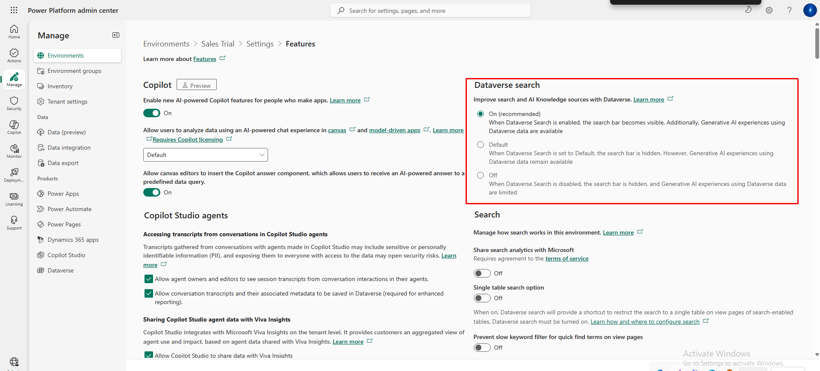

4. Create a Custom Table & Add Columns
We will create a custom table (e.g., "Vehicle") and add custom columns to it.
- Log in to the Power Apps Maker Portal (make.powerapps.com).
- Ensure the correct Environment is selected in the top-right corner.
- Navigate to Solutions on the left menu.
- Open an existing unmanaged solution or click + New solution to create one (Recommended).
- Inside the solution, click + New > Table > Table.
- Enter the details:
  - Display name: Vehicle
  - Plural name: Vehicles
  - Primary Column: Name (Default)
- Click Save.
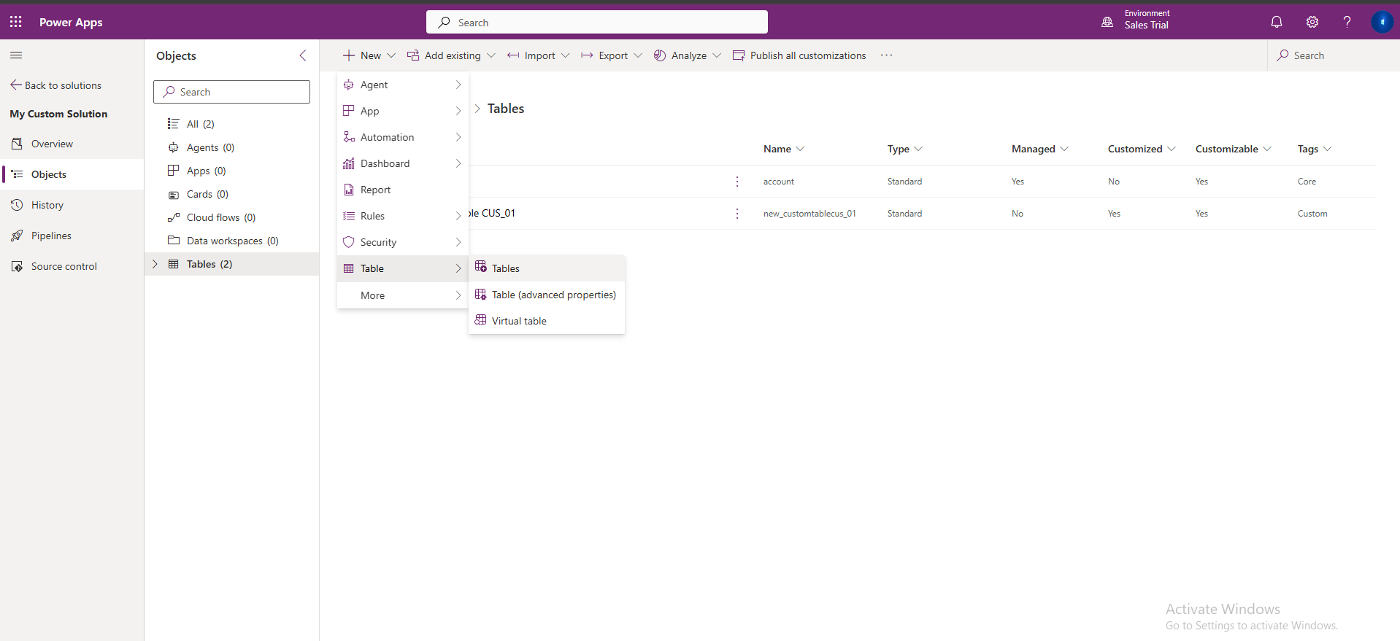
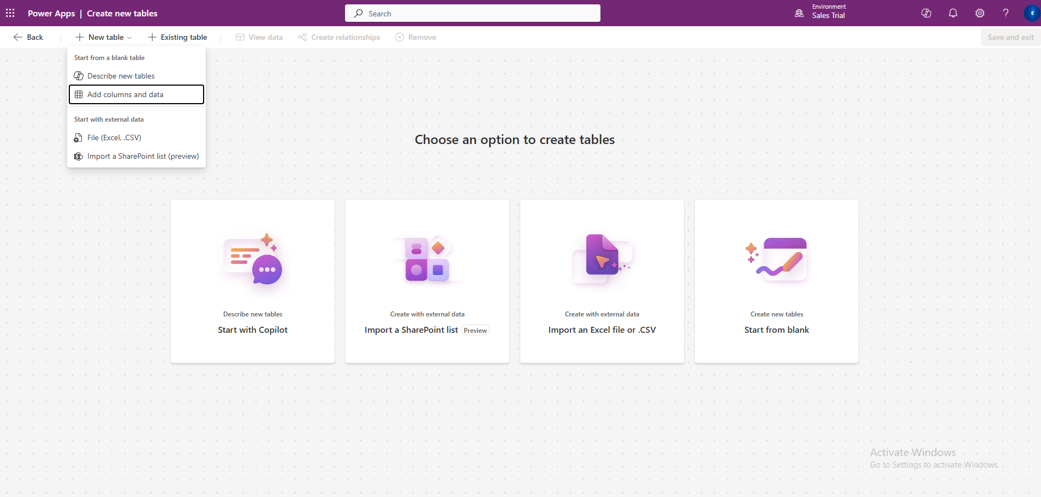
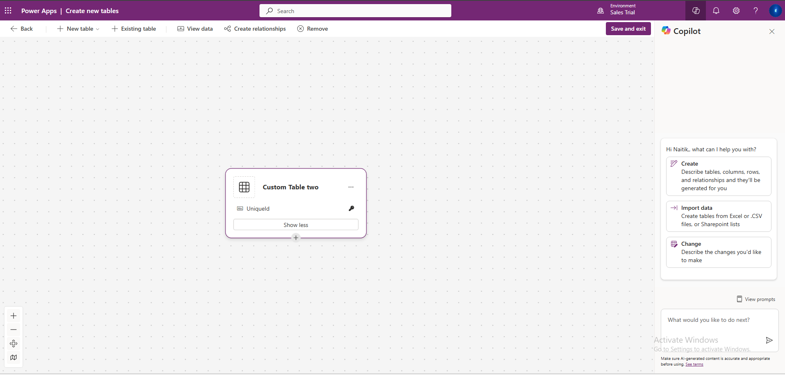

Add Custom Columns
- In the Table Designer, under the Schema section, select Columns.
- Click + New column.
- Create a column for testing search (e.g., License Plate).
  - Display name: License Plate
  - Data type: Text
- Click Save.
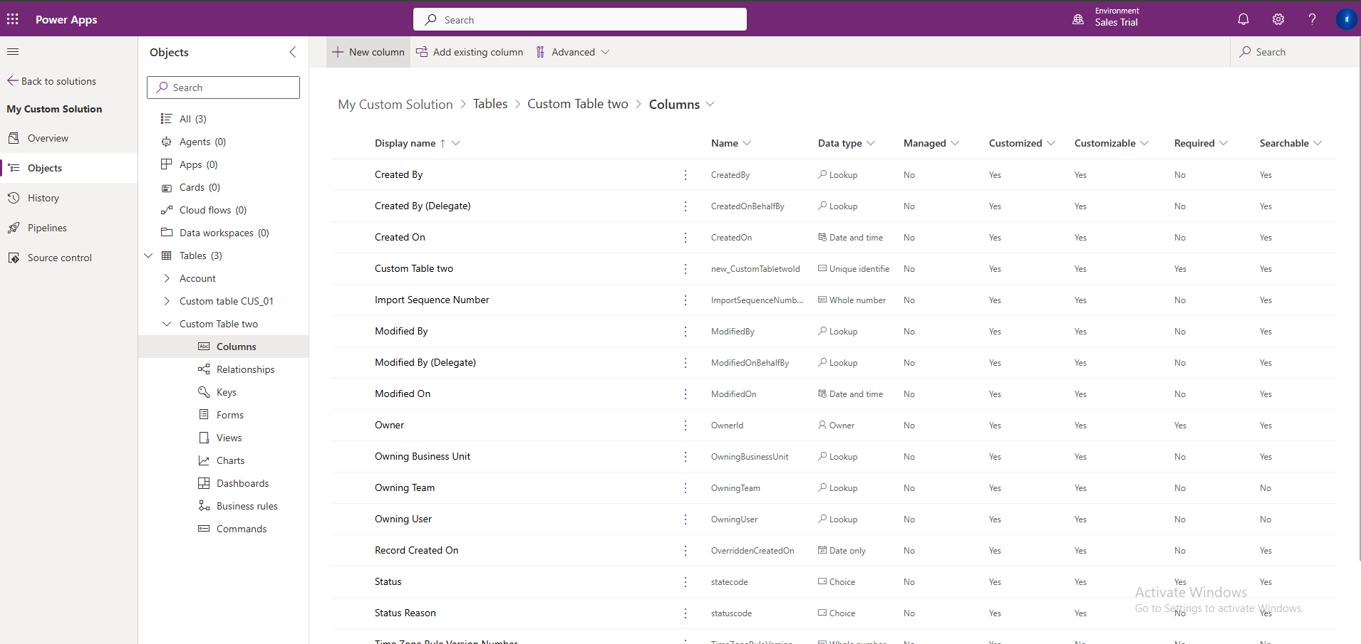
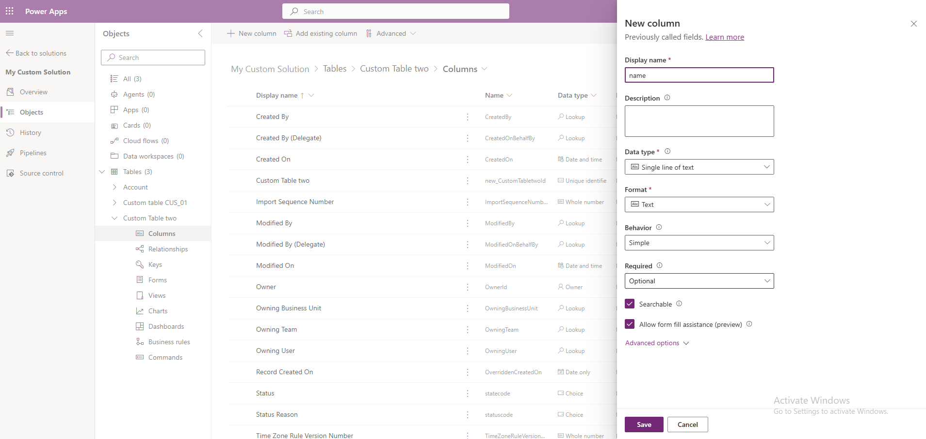

5. Create Relationship to Account
To associate this custom object with an Account (so the API can fetch the parent Account), we must create a relationship.
- In the Table Designer for your custom table, go to Relationships.
- Click + New relationship > Many-to-one.
- Configure the relationship:
  - Related (One) Table: Select Account.
  - Lookup column display name: Account (or Owner Account).
  - Lookup column name: Note this name (e.g., new_accountid or cr56_accountid).
- Click Done.
- Click Save Table to apply changes.
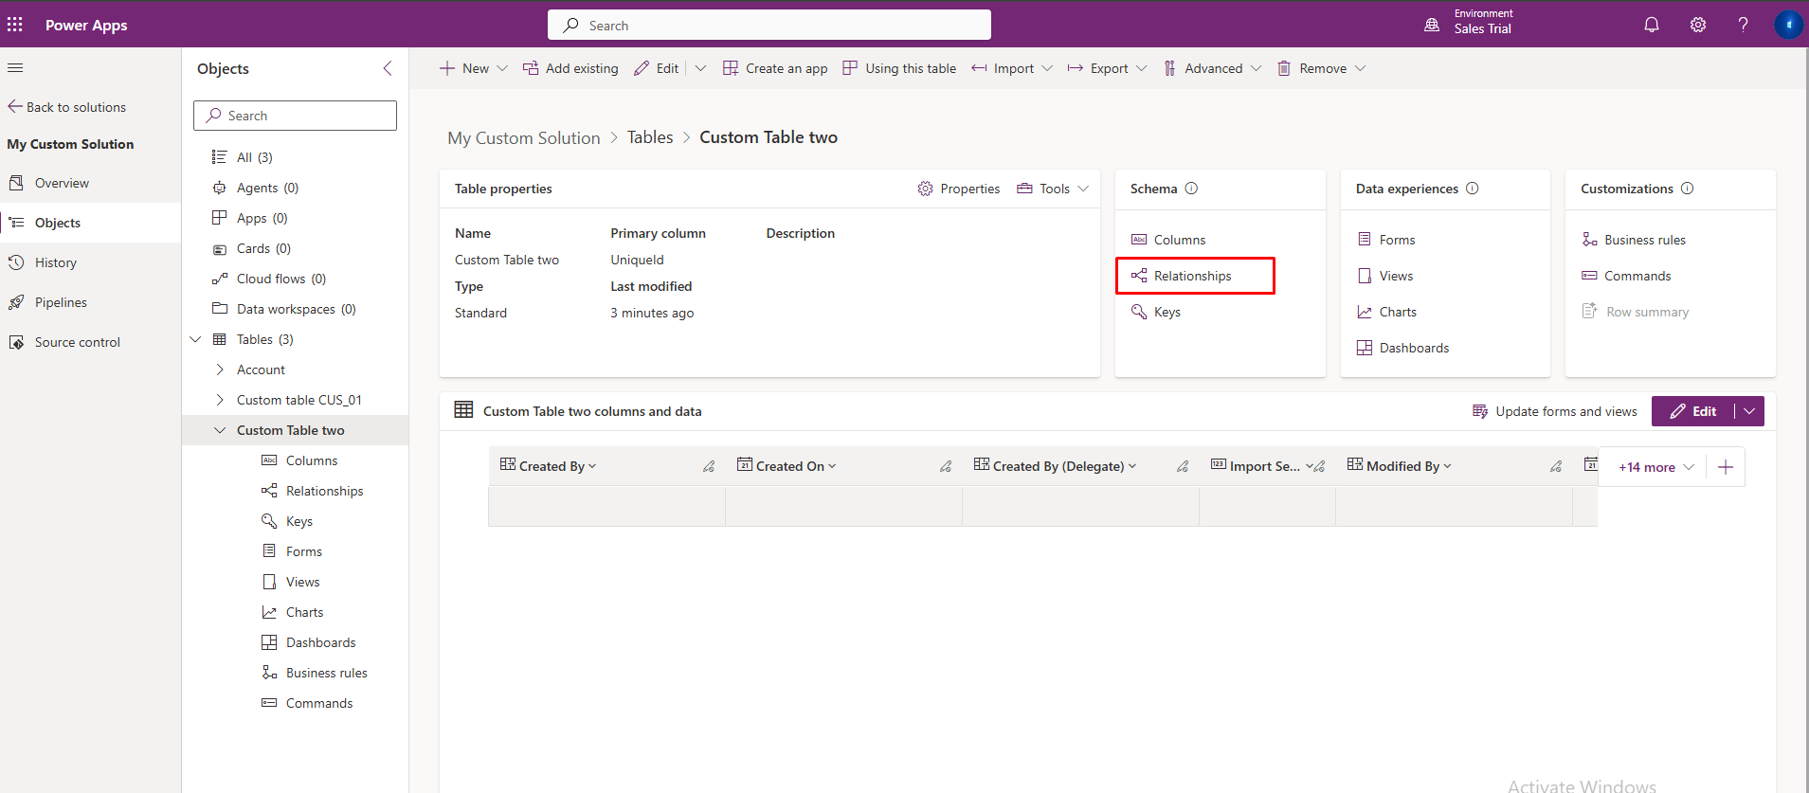
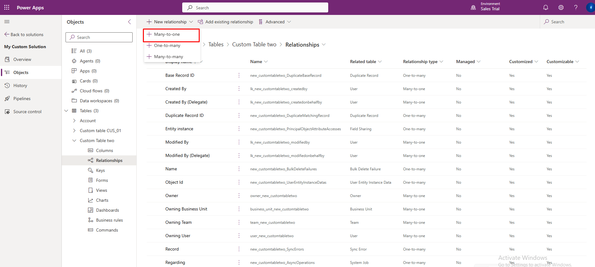
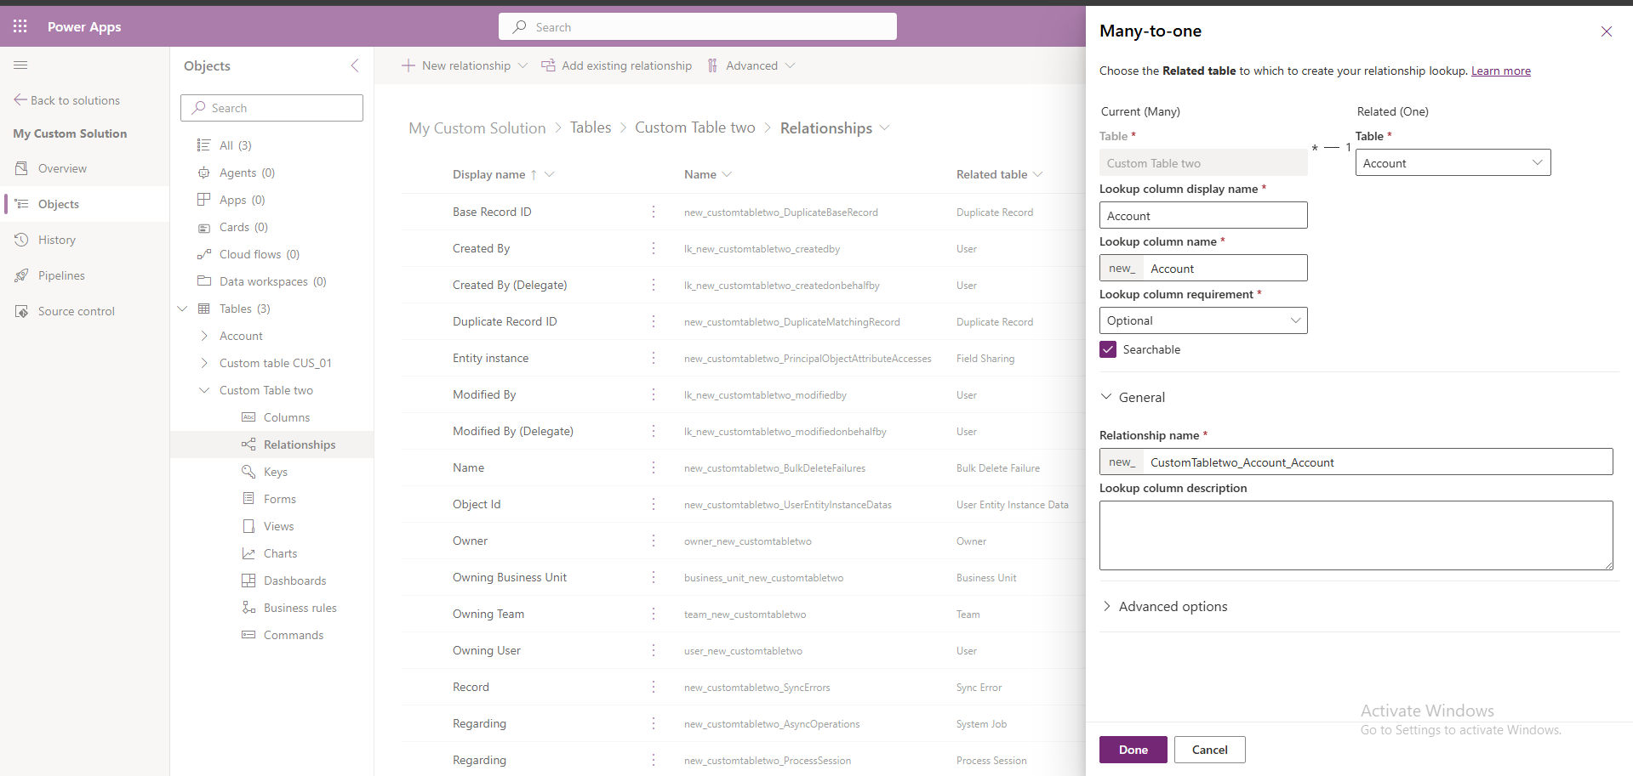

6. Enable Search for the Custom Table
Creating the table does not automatically make it searchable via API. You must explicitly enable indexing.

Step A: Enable "Appear in search results"
- While in your Solution, select your Custom Table.
- Click Properties (in the top menu or the Settings gear icon).
- Expand Advanced options.
- Scroll down to the "Rows in this table" section.
- Check the box Appear in search results.
- Ensure Track changes is also checked (this is required for search indexing).
- Click Save.
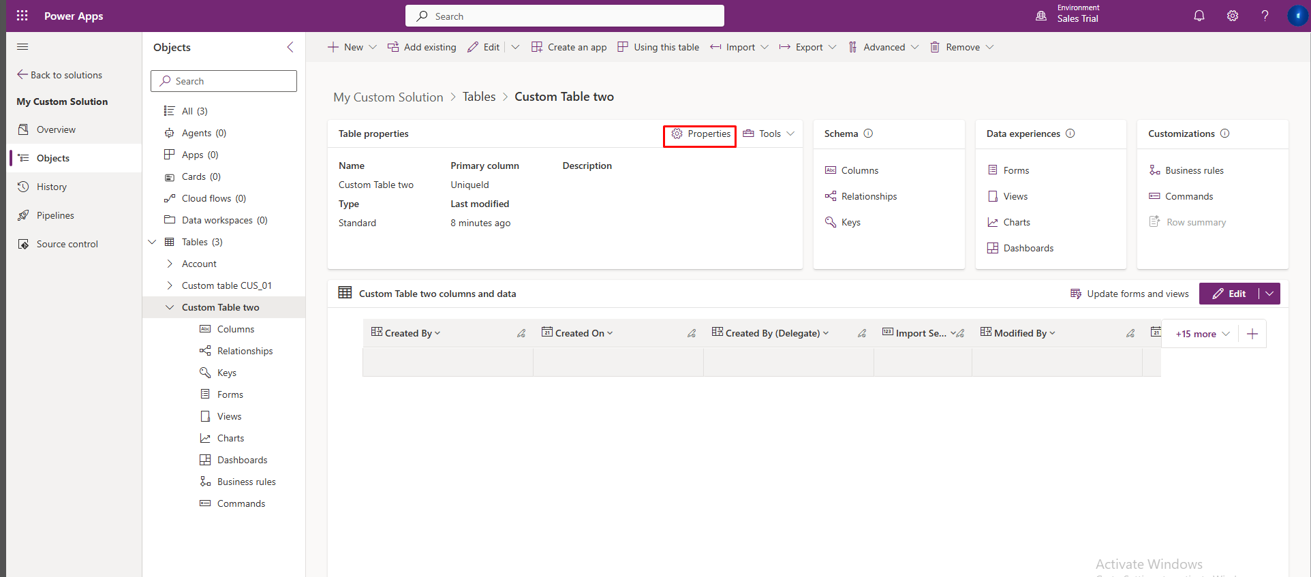
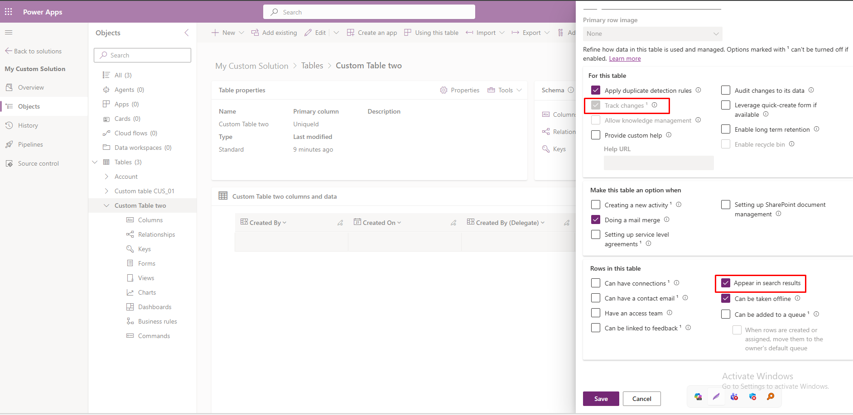Step B: Configure "Quick Find" View (Crucial)
Dataverse Search only indexes columns defined in the "Quick Find" view.
- In the Table Designer, go to Data experiences > Views.
- Click on the view named Quick Find [Your Table Name].
- Look at the configuration panel on the right (or bottom).
- Click Edit find columns.
- Check the boxes for every column you want to be searchable (e.g., Name, License Plate, ID).
  - Note: If a column is not checked here, the API will return 0 results when searching for data in that column.
- Click Apply.
- Click Save and publish in the top right corner.
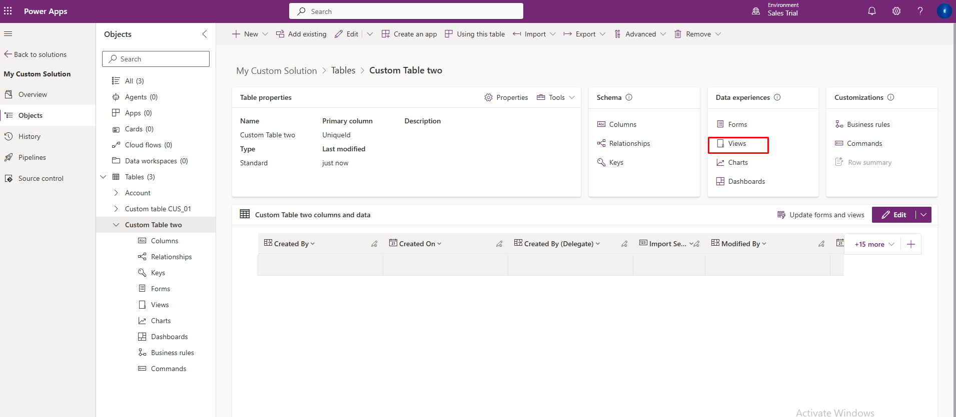
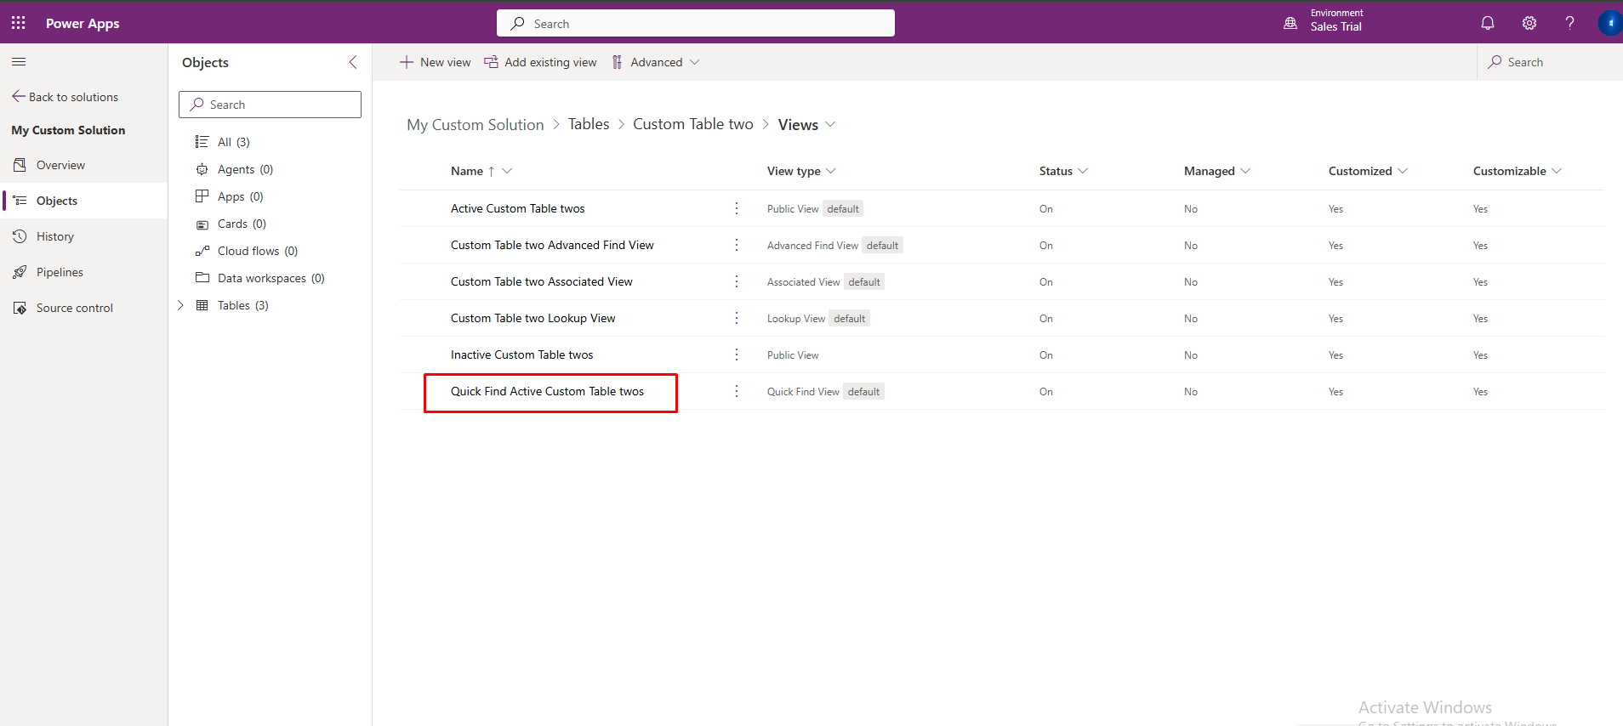
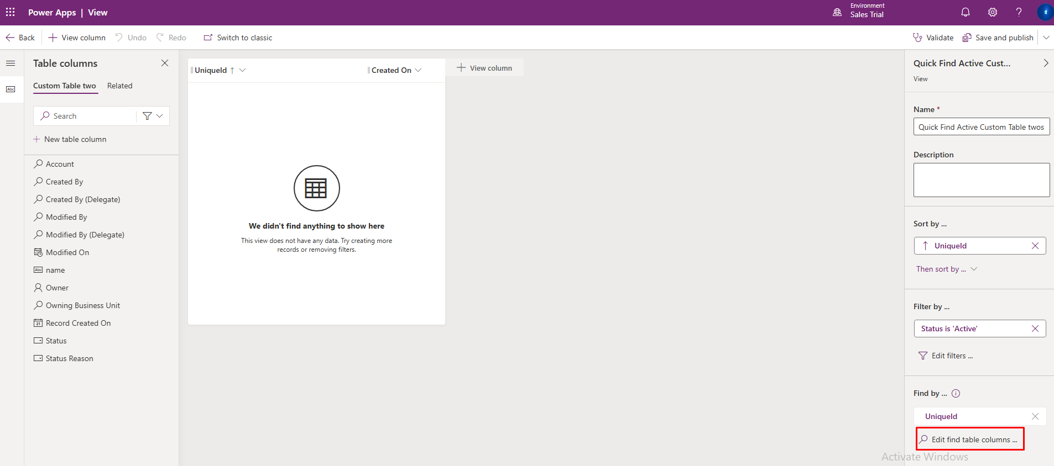Step C: Add to Global Search Index
- Navigate back to the main Solutions list (click "Solutions" on the left).
- Click Overview on the left menu (or "Solution overview").
- Locate the card labeled Dataverse search.
- Click Manage search index.
- In the list of tables, search for your custom table (Vehicle).
- Check the box next to your table.
- Click Save.
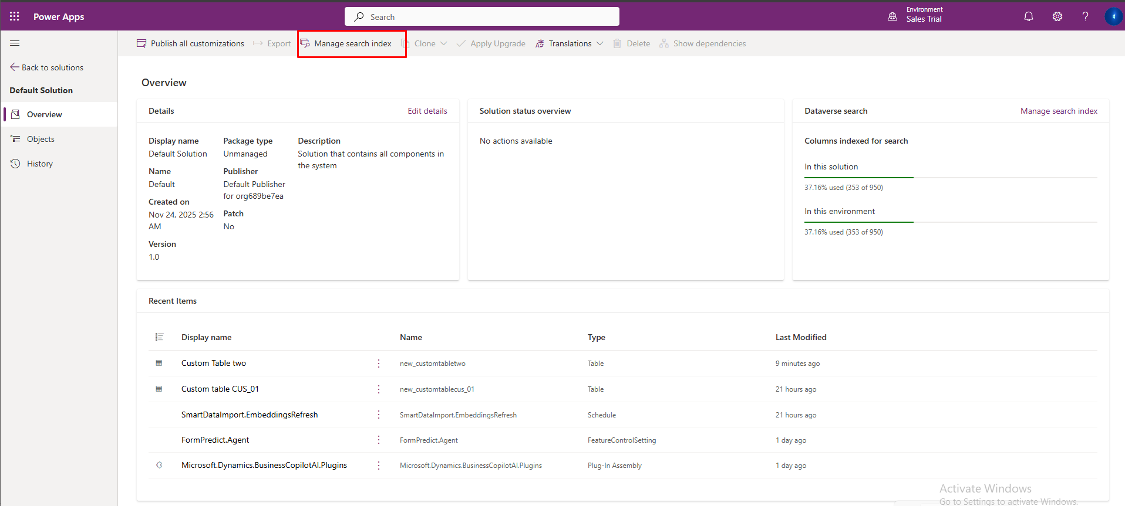
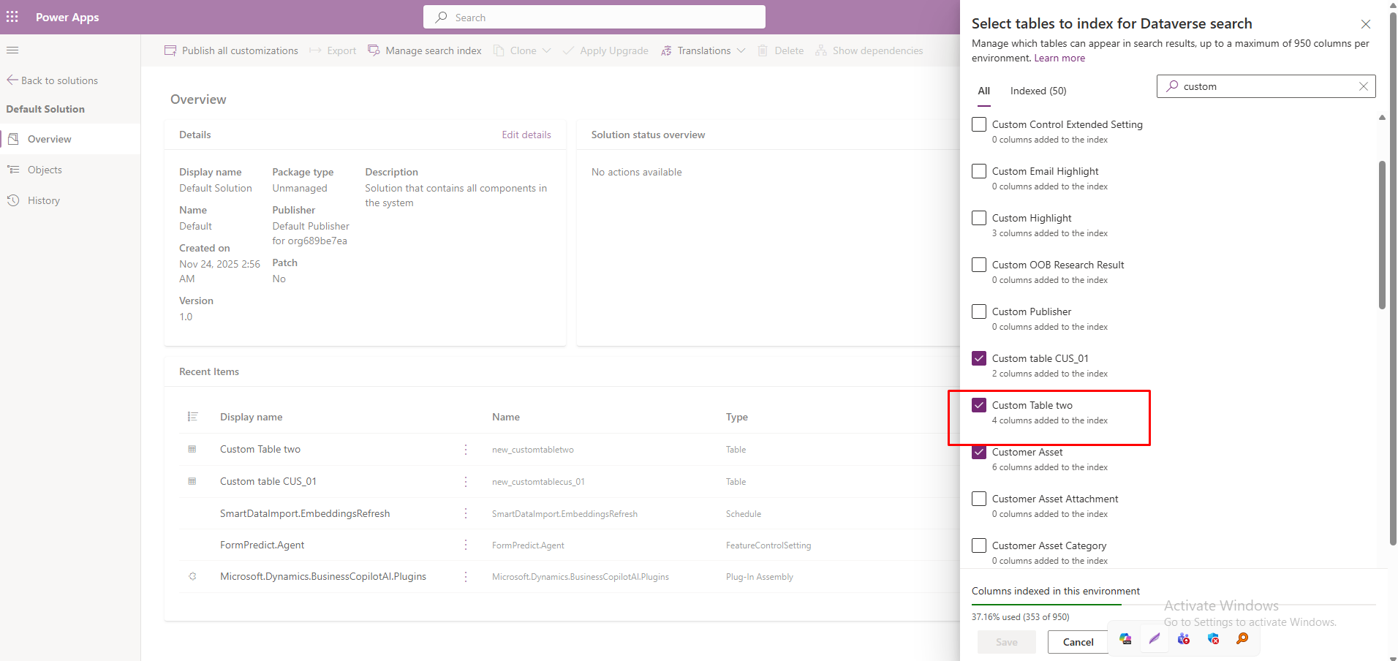

7. Validation & Indexing Time
Indexing Delay
Once the configuration is saved, you must wait.
- Wait Time: 15 to 60 minutes.
- The API will return empty results ([]) or partial results until the background indexing process completes.

8. Add Custom Table to the Application (e.g., Sales Hub)
Even after creating the table, it might not be visible in the Dynamics 365 menu. You must add it to the Model-Driven App you are using.
- Go to the Power Apps Maker Portal (make.powerapps.com).
- On the left menu, select Apps.
- Find the app your organization uses (e.g., "Sales Hub" or "Customer Service Hub").
- Click the ... (More Options) button next to the app name and select Edit.
  - This opens the App Designer.
- In the App Designer:
  - Click + Add page (Top left or center).
  - Select Dataverse table.
  - Click Next.
  - Search for your custom table (e.g., Vehicle).
  - Check the box next to it and click Add.
- Save the App.
- Publish the App.
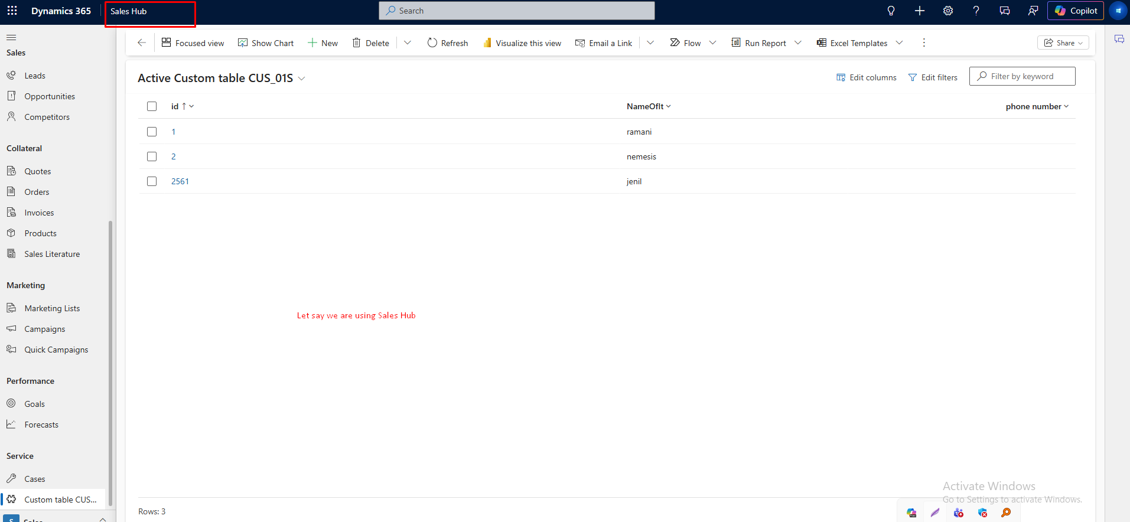
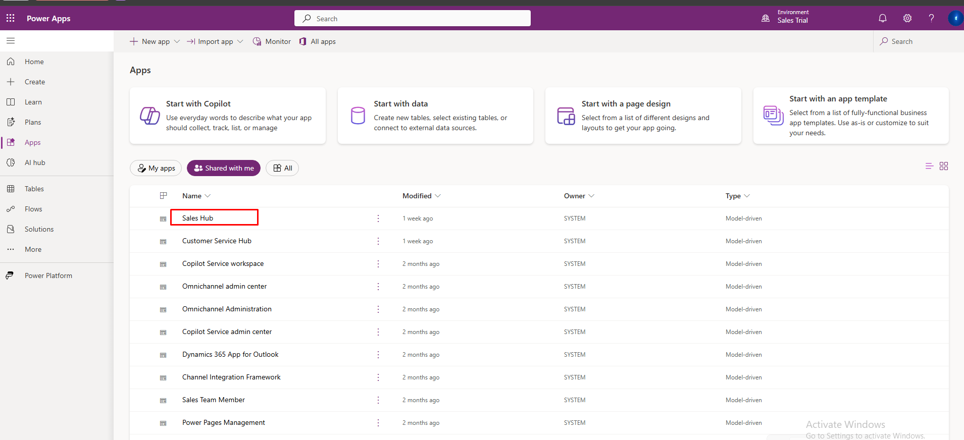
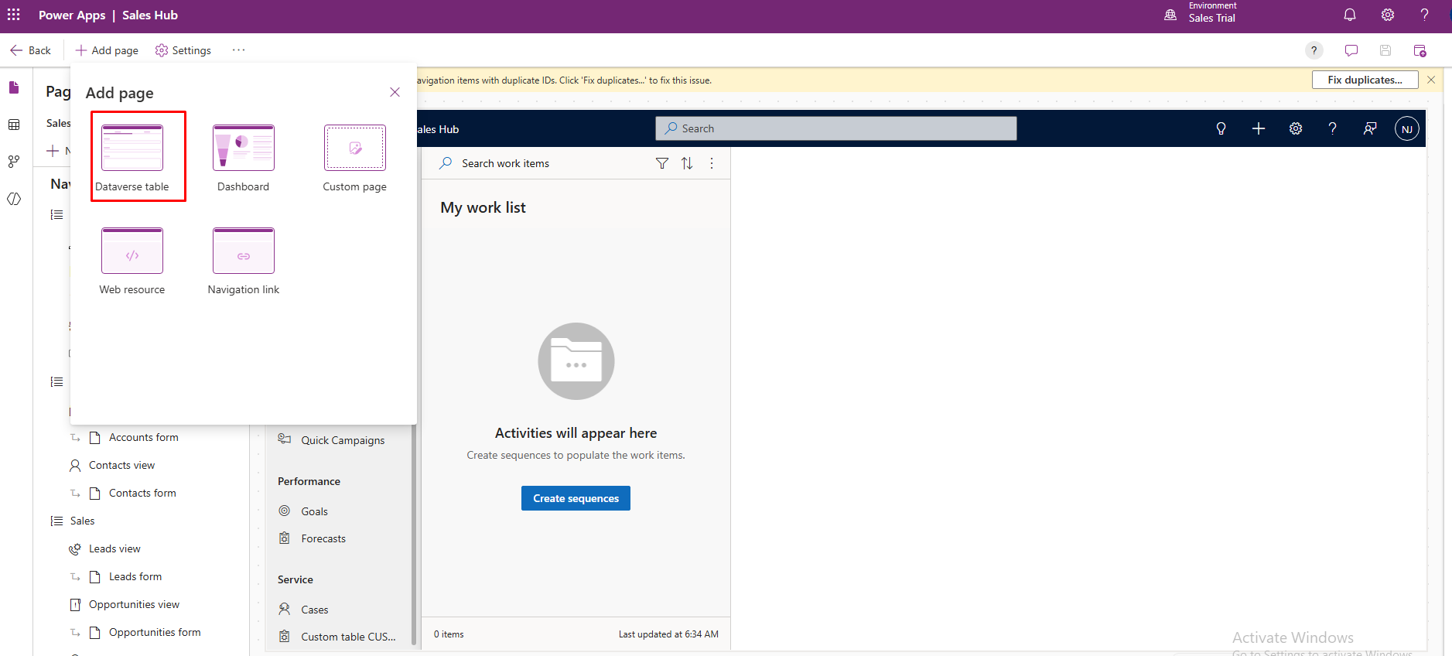
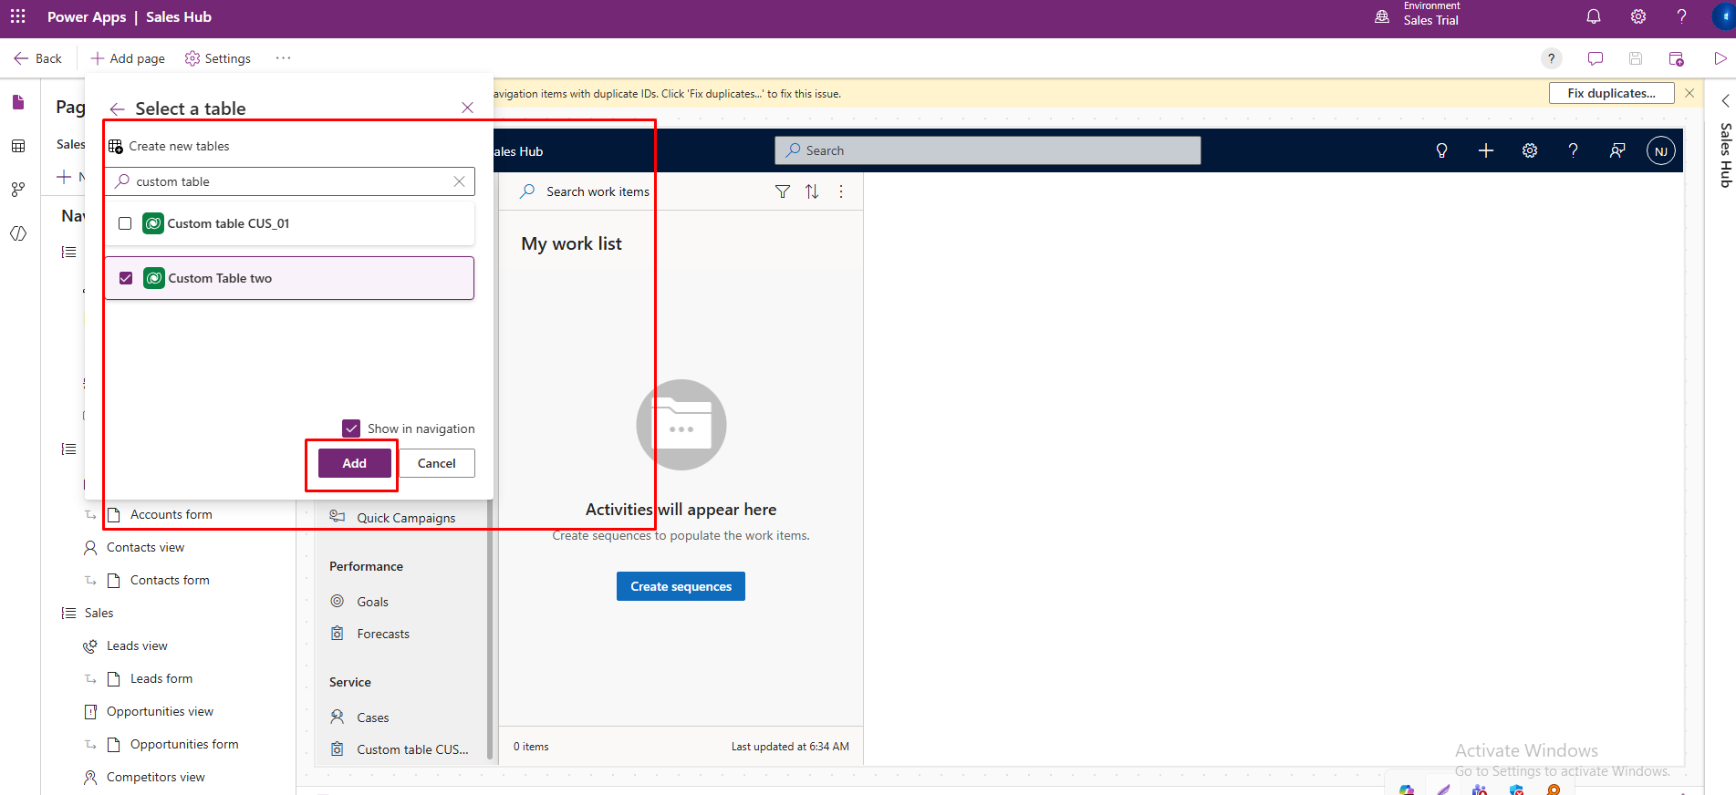
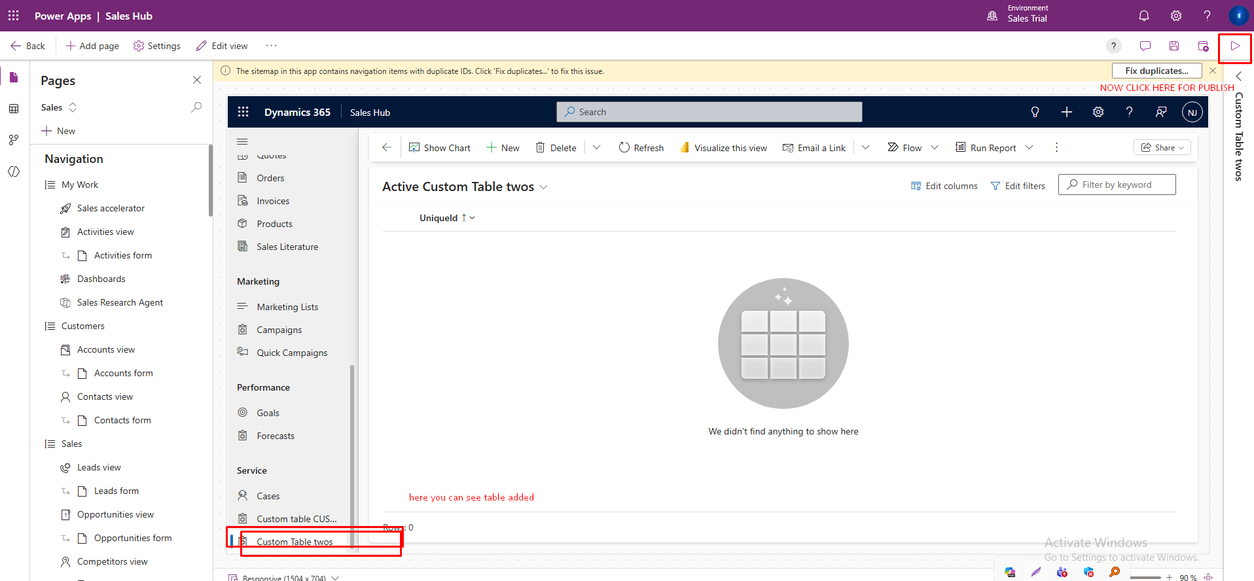

9.Add to a Specific Group/Area
If the table was added but appeared in a random spot, you can move it.
- In the App Designer, look at the Navigation pane (Left side).
- Expand the grouping where you want the table (e.g., under "Customers" or "My Work").
- Drag and drop your Vehicle view into that group.
- Publish again.
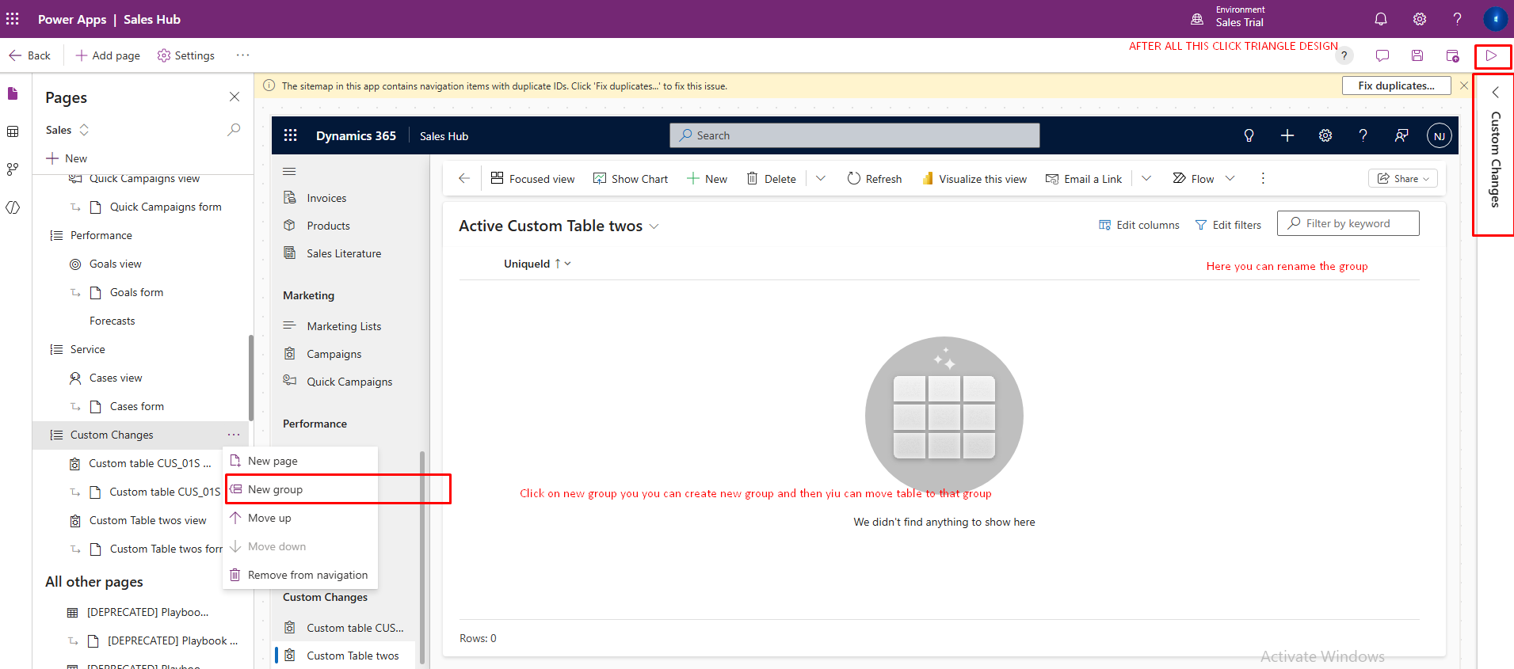

10. Final Step: Publish All Customizations
To ensure all changes (Columns, Views, Search Configuration, App Navigation) are fully applied and live, perform a global publish. This is a crucial step to resolve issues where the API returns old data or 0 results.
- Go to the Power Apps Maker Portal (make.powerapps.com).
- Click Solutions on the left menu.
- Look at the top command bar (do not select a specific solution yet).
- Click Publish all customizations.
  - Note: This process can take 1-5 minutes to complete. Please wait until the success notification appears.
